* Working Software:-

The second principle says Working Software over comprehensive documentation. Do you sometimes feel like your group is investing more energy in documenting your system rather than building it? Hence one of the major obstacle to progress in a software project is documentation. The Agile Manifesto recommends that groups should value working software over far reaching documentation. It does not mean that you should not focus on documentation, it implies that you should make documentation that offers some value and simultaneously does not hinder the team project. Composing documentation particularly towards the start of a project has numerous drawbacks. Delivering the software that does what it should come first in the priorities before creating documentation, so as per the meaning we should provide a software which will help the users in ranking their websites. For ranking a website we need a software which is called as SEO tool or keywords. There are many SEO keywords available on internet such as SEMrush, MOZ Pro, Conductor, SE Ranking, etc.

What is the work of keyword?

The work of these keywords is to investigate the potential of Web pages for high placement on search engine ranking pages. They provide information on backlinks and keywords as well as insights into competition on the Internet. Web optimization apparatuses (the technical equipment or machinery needed for a particular activity or purpose) help site proprietors to rank higher in web crawler results.

* Individuals and Interactions:-

The first principle says Individuals and interactions over process and tools. In order to make a website efficient the developer should interact with the people, discuss with them and then make a working software. Let us take an example: suppose the developer has make a website for Bikaner. In his rivalry Haldirams has also make the website. Now both the websites will show the detail of the food items, sweets, bakery and various types of Indian snacks and also show the price as per the item. Now suppose user want to eat something. He type sweet and food in. Now suppose at first the Haldiram website pop up before Bikaner. Then obviously the user will first visit the recommended website. So in this case there may be a loss for Bikaner until and unless the user only want to have a food from Bikaner because instead of having a better taste and less price as compared to Haldiram the user order from Haldiram.

So in order to display our website on top of search we have to add some special keywords in our website and have to search it again and again. But this process of keyword and search takes a lot of time and instead of giving a good interface to website the developer is busy in finding the keyword. So to remove the burden on developer we will use RPA. We will assign all this work to a robot and function the robot using AI (Artificial Intelligence). The robot will do all this work and the developer can interact with other website and people in order to make the website user friendly and effective.

# ER-Diagram

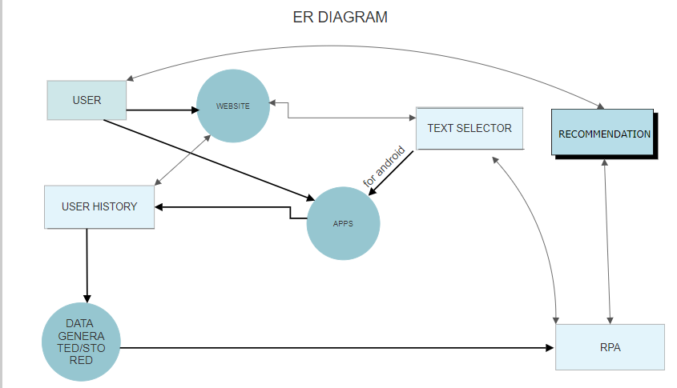

### RPA: -

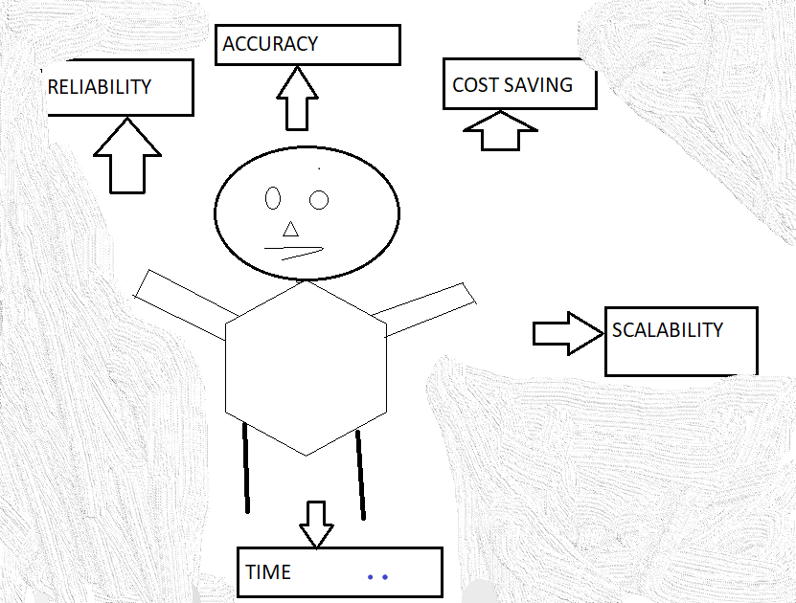

# Data Flow Diagram: -

# C:\Users\Admin\Desktop\Presentation_H4\AGILEdataf.PNG